CGPM

Pragun : Audio analyze code and relevant graphs or any other details

Rohit: Stage Modelling

Tanya: Connecting both the software and Abstract, introduction, any future scope of work

Divyanshu: Algorithm Details

Stage Modelling

Stage was modeled in Unreal Engine 4.23. Stage unit consists of a floor for audience, a raised stage for singer and 9 spotlights. A singer was also modelled and has basic movements like walking and jumping. The spotlights changes their color intensity based on inputs from given song.

Image represent blueprint for a blinking spotlight. 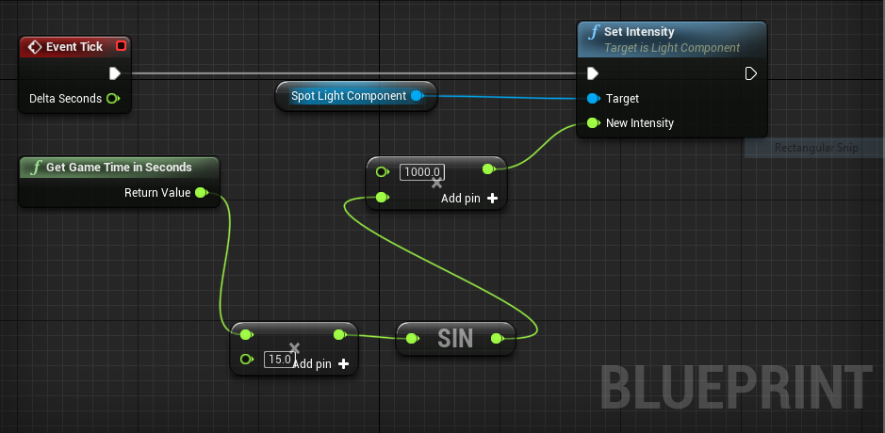

At each instant, **Event Tick** module asks **Set Intensity** module to set intensity of spotlight based on inputs to **New Intensity** value. **Get Game Time in Seconds** sends game time as input to a multiplier module. The output is then feed to sin function and then to another multiplier. Sin function enables fluctuating nature of light and multipliers alters frequency of fluctuations and boost intensity of light.